Dig Deeper
John 8:12
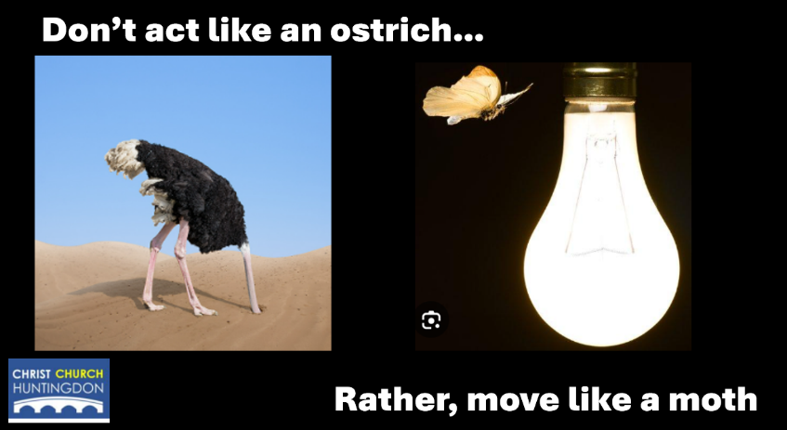

- What does it mean for Jesus to say, ‘I AM the light of the world?’

You could discuss…
- Jesus’ divine identity (One of the I AM sayings – links to Yahweh and the pillar of fire in Exodus 13)
- Giving sight to what God the Father is like (John 14:9)
- Revealing people’s sin and love of evil (John 3:16-21)
- Leading people to belief and eternal life (John 8:12, John 12:44-50)
- Showing people a way back from exile/separation from God (Isaiah 9:2, John 3:16-17)
- Guiding people’s feet onto the path of peace (Luke 1:79)

- What comfort does knowing Jesus as the light of the world bring?
- Both in general to all believers and to me personally

- When and why might we be tempted to hide from Jesus the light of the world?
- Both in general to all believers and to me personally

- What should we do/how can we help each other when this is the case?

- When and why might our non-Christians friends hide from Jesus the light of the world?
- Both in general to all non-believers and my friends personally (so we can be praying for them)

- How can we follow up when they do?

- What does it (and what does it not) mean to say, ‘You are the light of the world.’ (Matthew 5:14-16)

- How should Jesus being the light of the world and subsequently us being the light of the world, change a heart attitude, a thought pattern or a behaviour this week?

